Module 2: Assignment – 1

1. Create 2 resource groups rg-1 and rg-2



2. Add storage account to rg-1

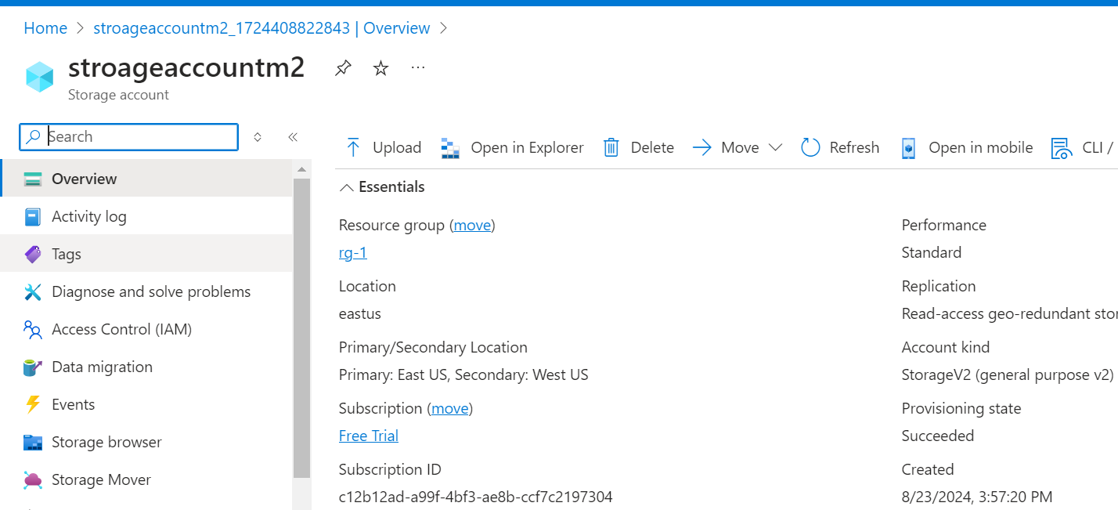

3. Move storage account from rg-1 to rg-2

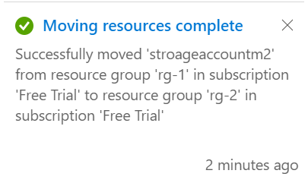

Module 2: Assignment – 2

1. Create 3 storage accounts with “Team” tags: team1, team2 and team3 respectively

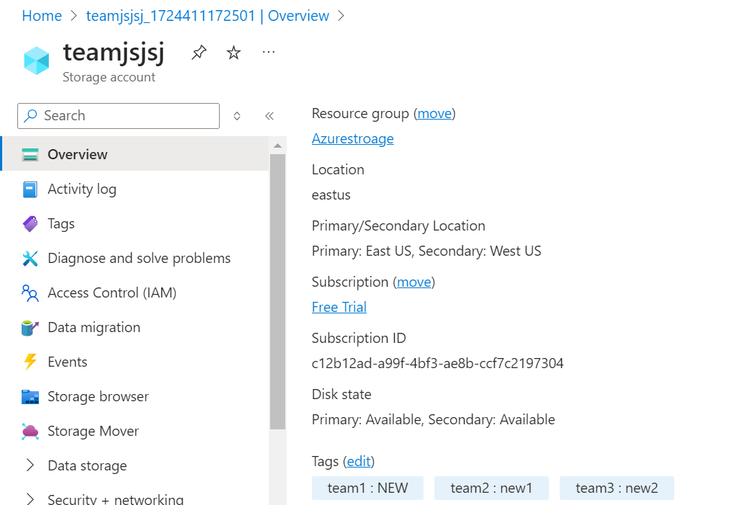

2. List all resources for team2 using tags

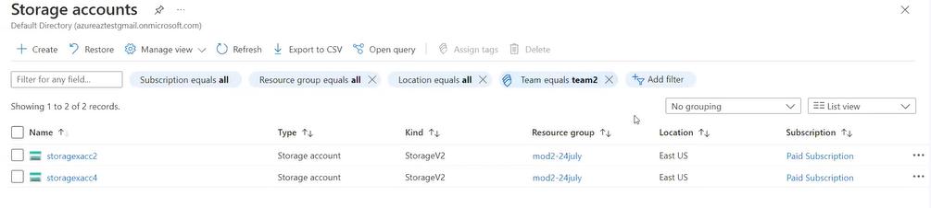

Module 2: Assignment – 3

1. Create a file share in Azure Storage

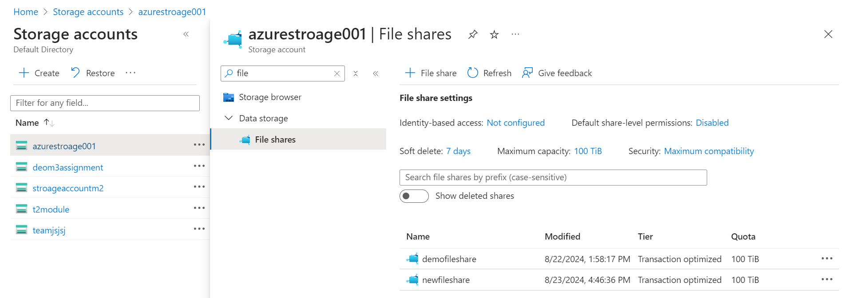

1. Mount this file share on Windows and Linux

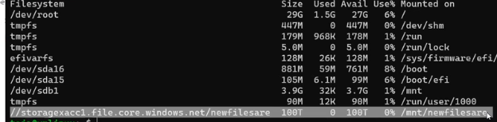

Module 2: Assignment – 4

1. Create a Storage account, and upload some files in Blob storage

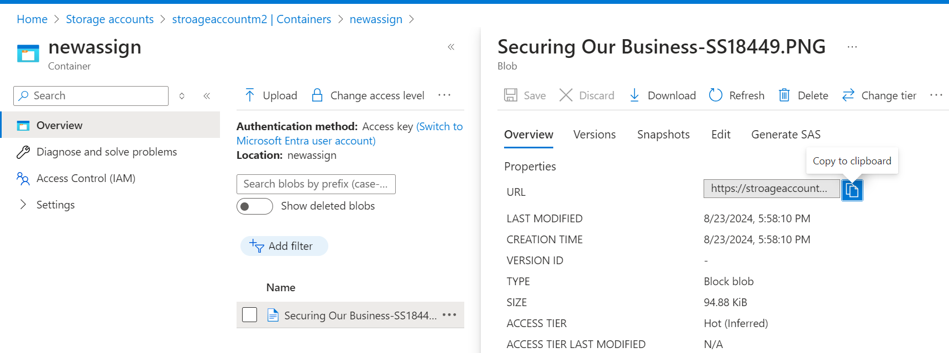

2. Create a CDN profile

No access was done while explaining assignments

Module 2: Assignment – 5

1. Create a storage account

Used existing account storage account

2. Use the Blob service and upload some files in it

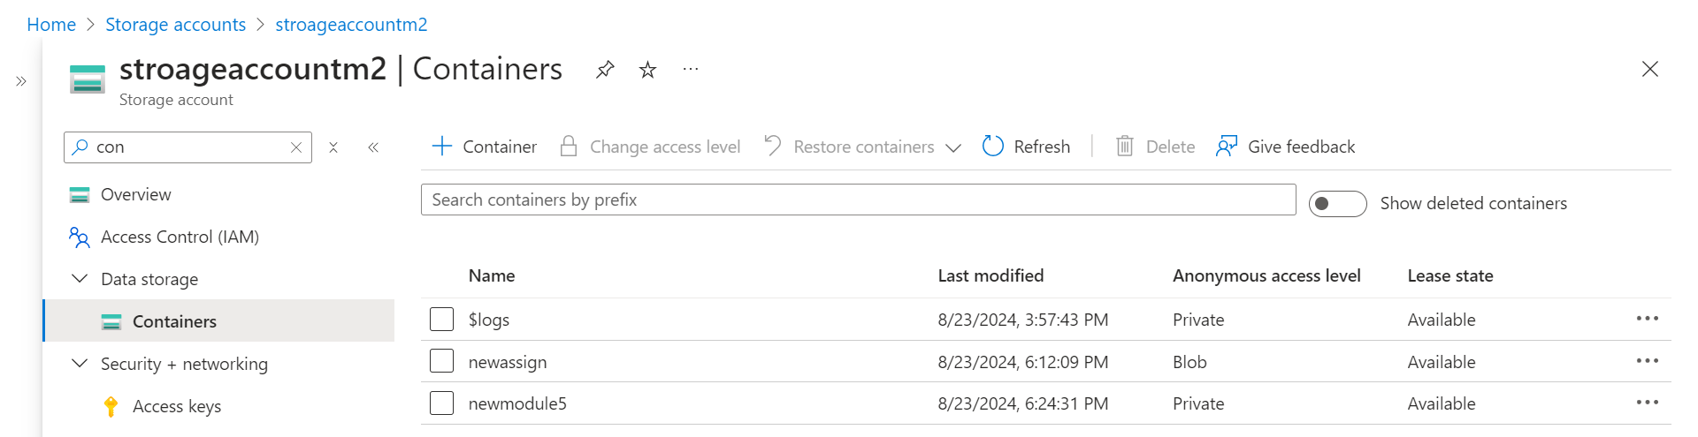

3. Change the access tier to archive

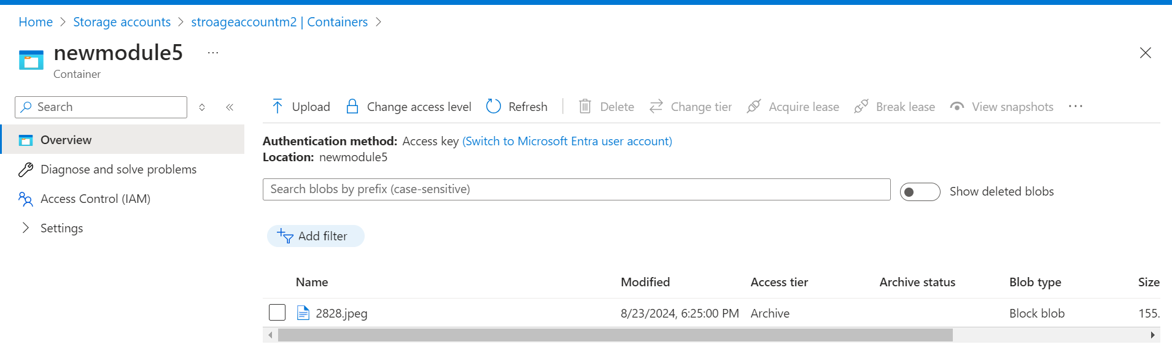

Module-3

1. Create a storage account

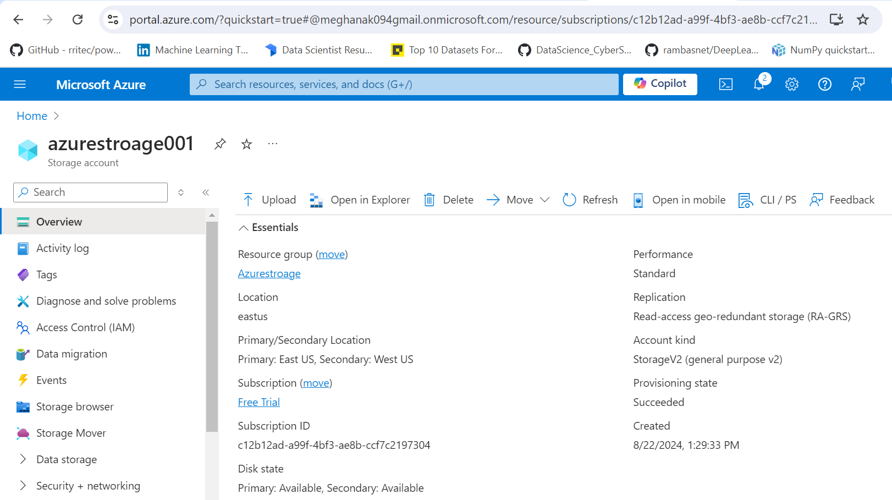

2. Connect Storage Explorer to this storage account

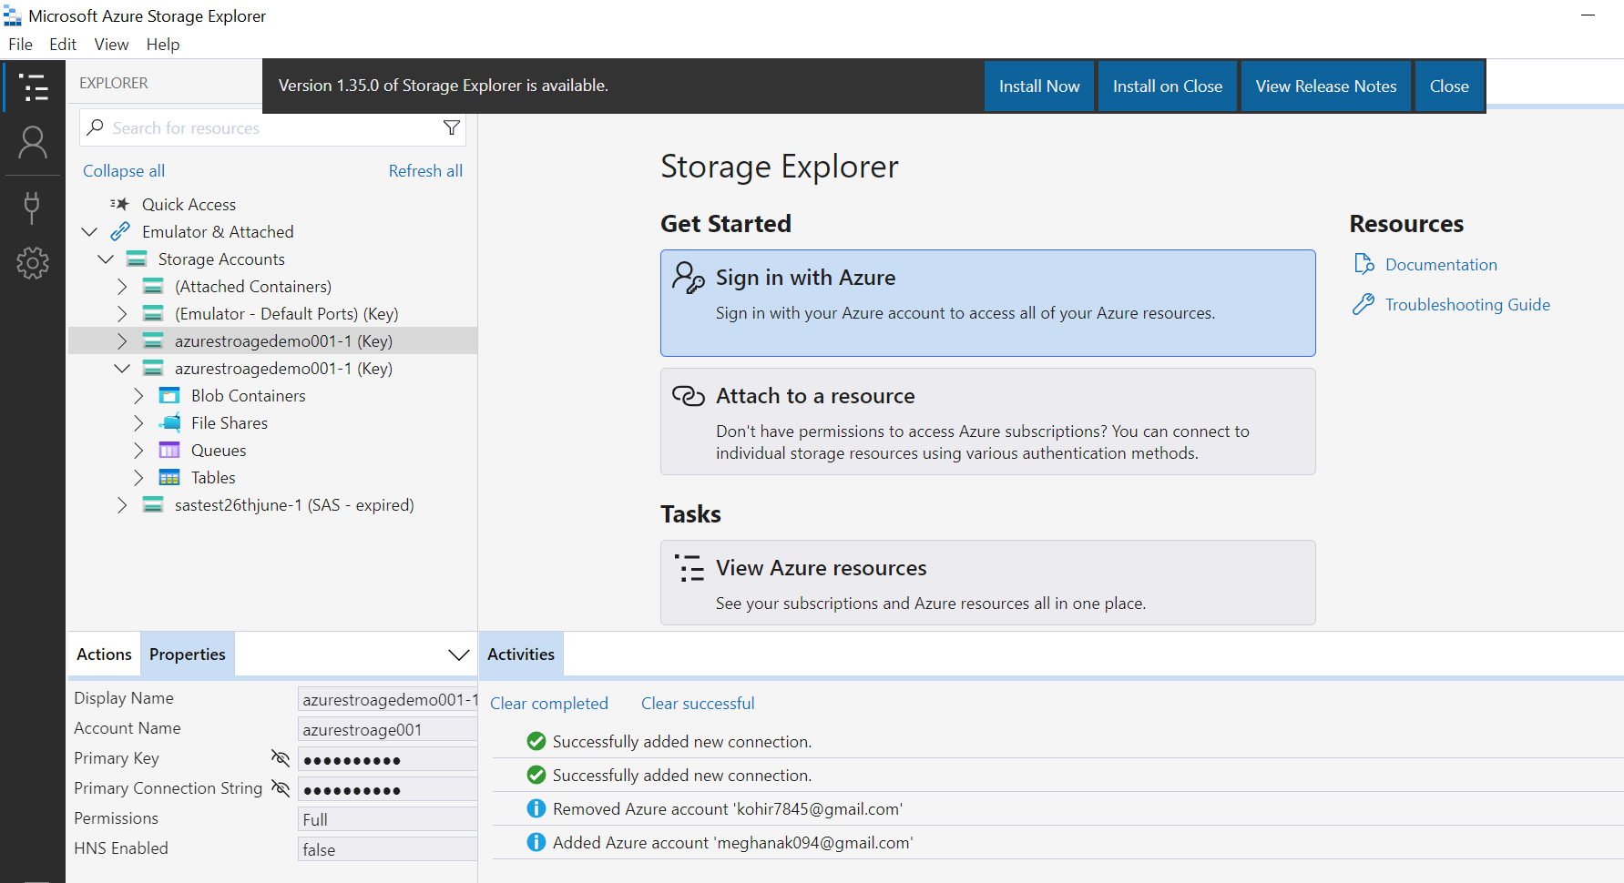

Module 3: Assignment - 2  
1. Create a file share using the Storage Explorer

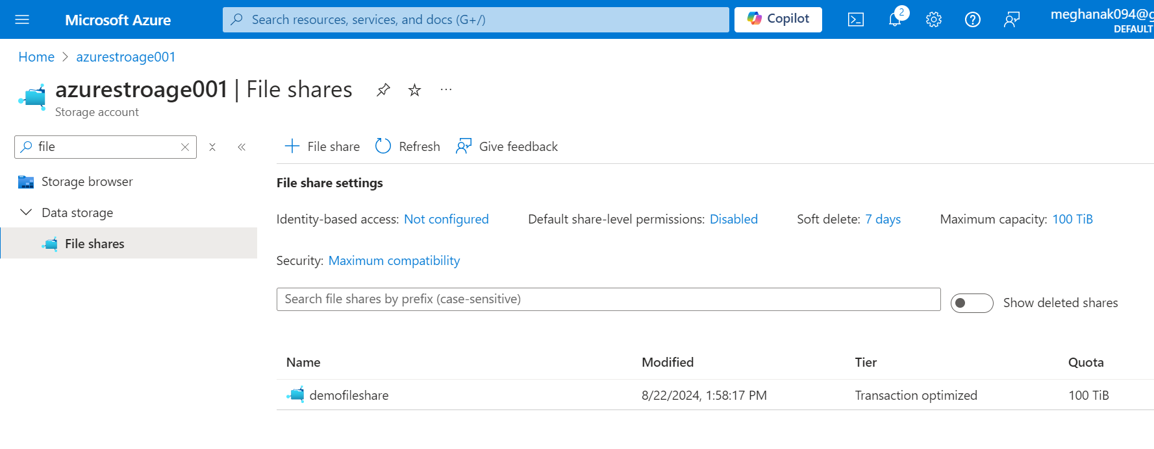

2. Upload files to the blob service

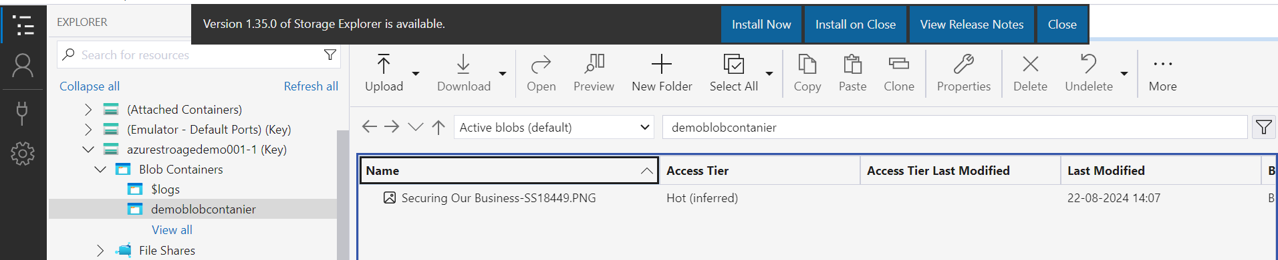

3. Create an Azure Table and insert a record

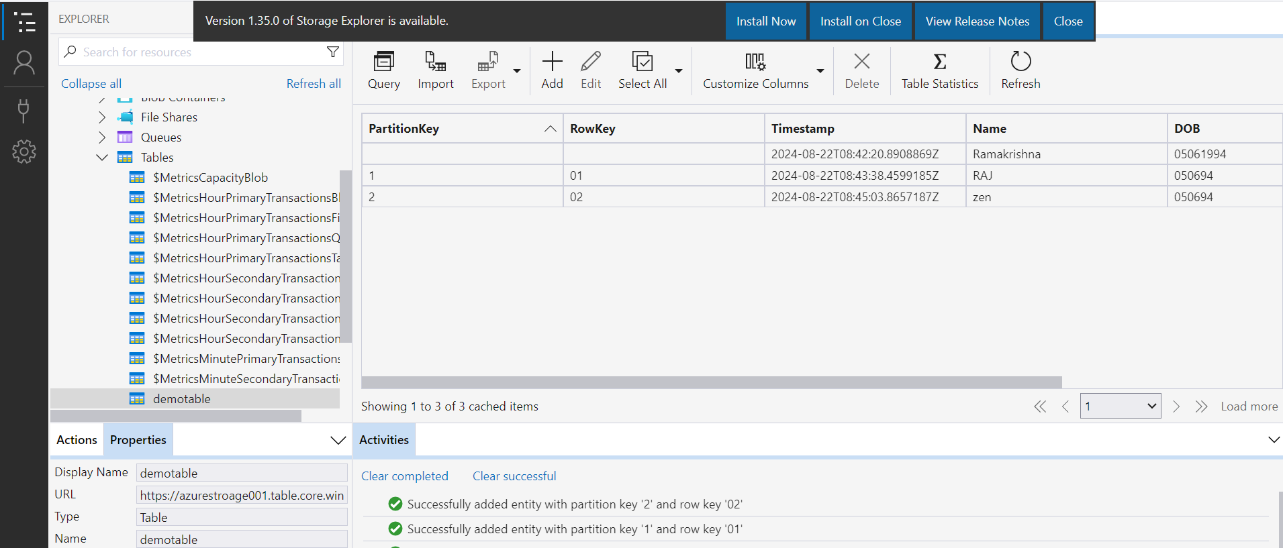

Module 3: Assignment – 3

1. Create two storage accounts and create a container inside it

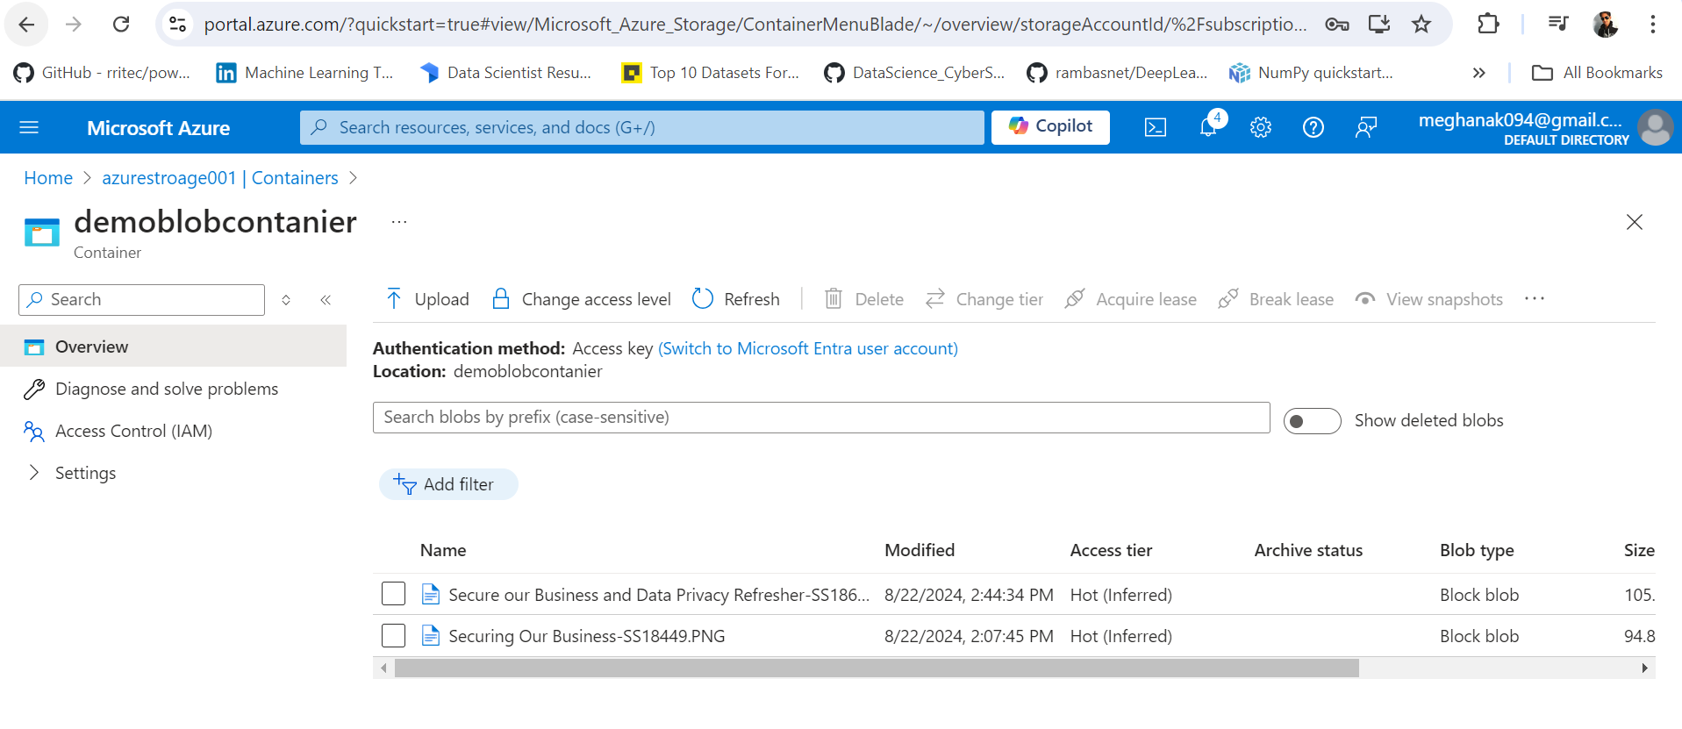

2. Upload some data to the first Blob service

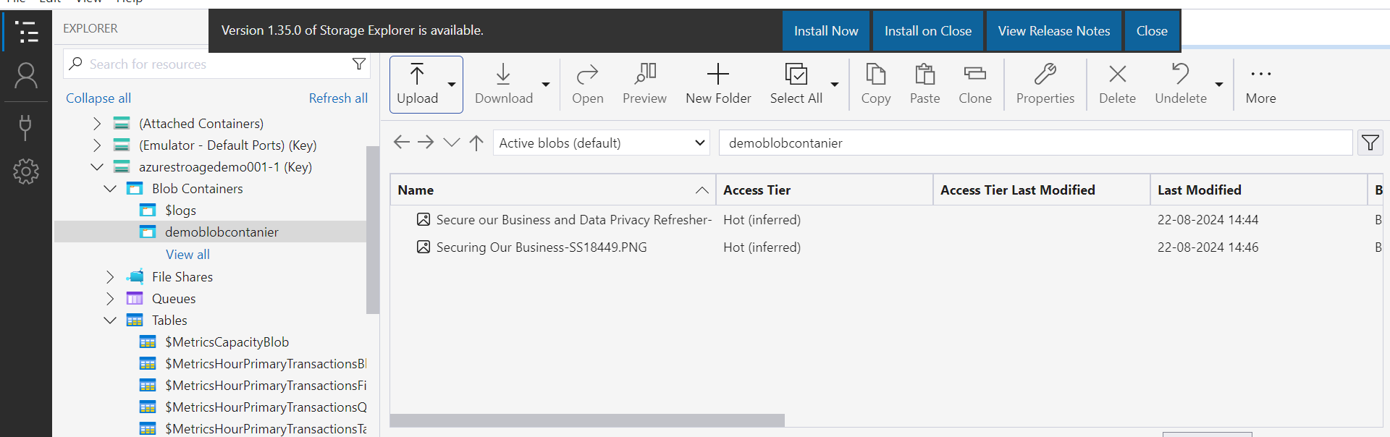

3. Using Data Factory copy data to the second storage service’s container

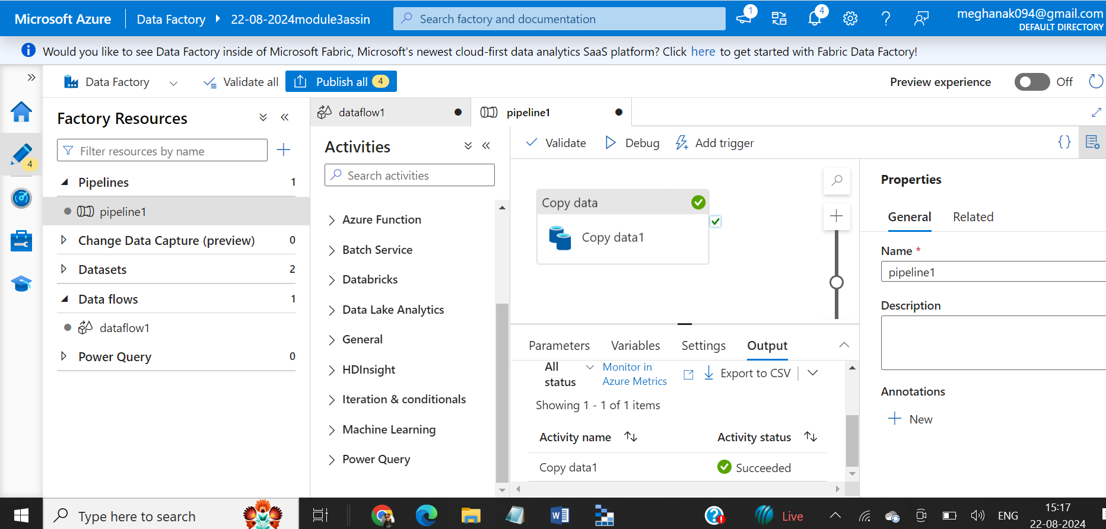

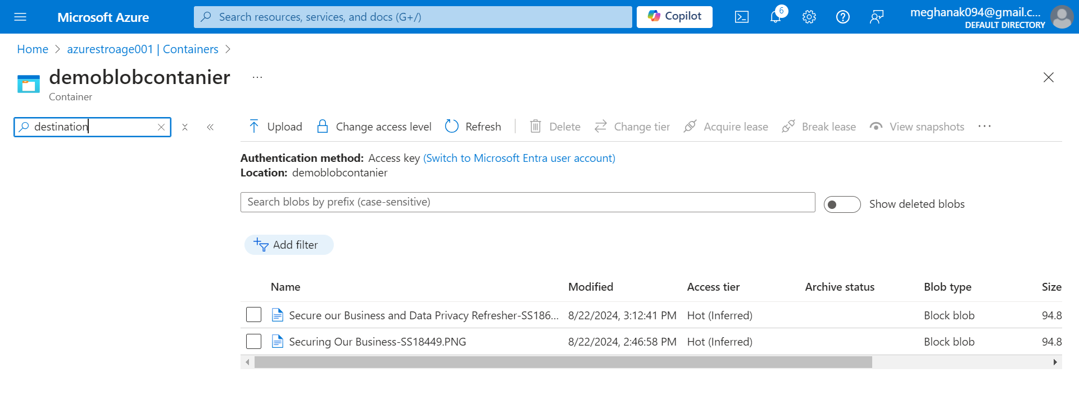

Module 3: Assignment – 4

1. Use the same storage accounts from a previous assignment

Used same accounts

2. Use Az-Copy utility to copy data from one storage container to another

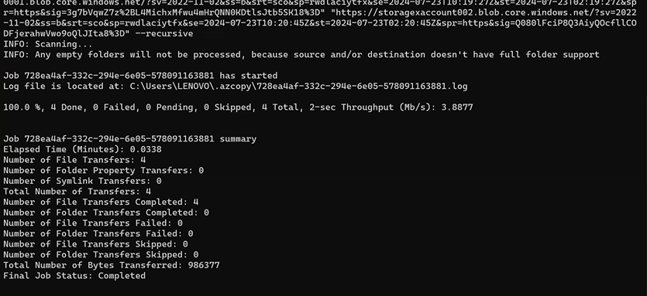

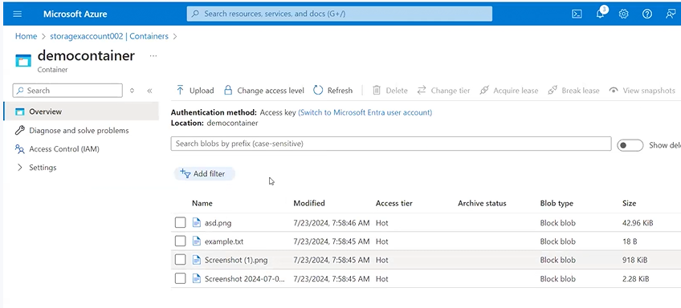

Module 4: Assignment – 1

1. Create a VM in the west US region

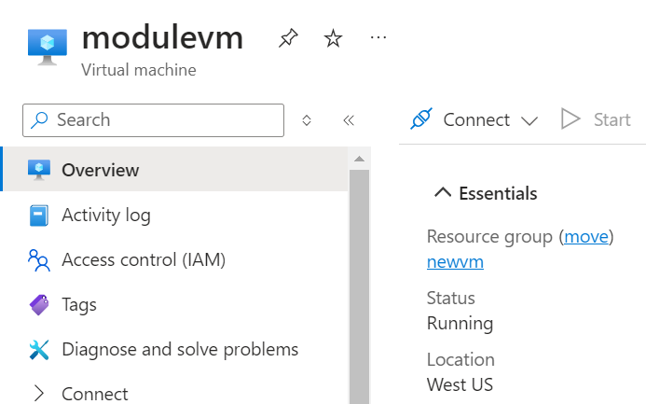

2. Select the Ubuntu image for creating the VM

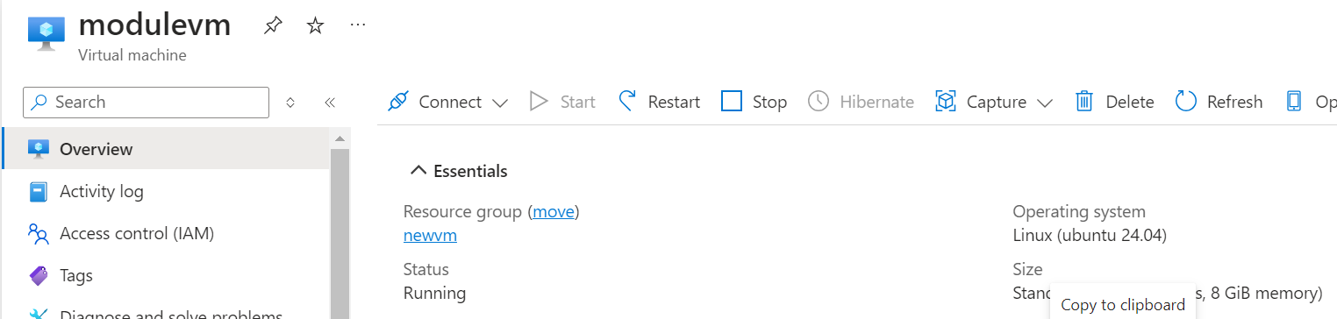

3. Open the SSH port

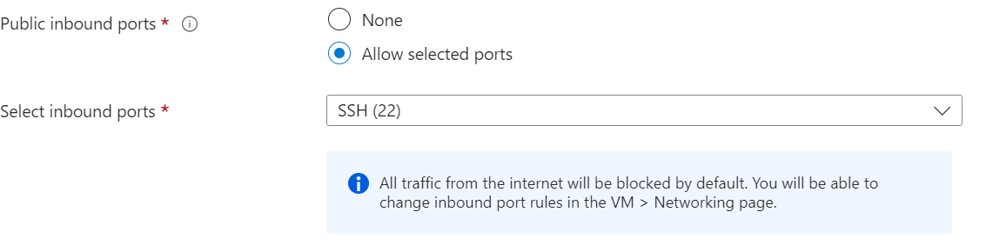

4. Connect to the Linux VM using the terminal

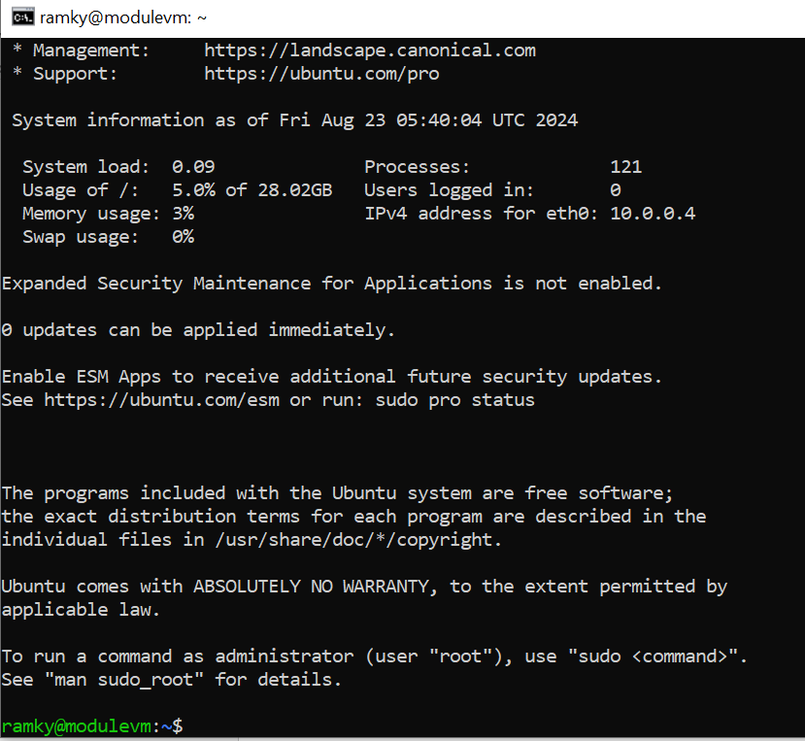

Module 4: Assignment – 2

1. Create a Windows VM in west US region

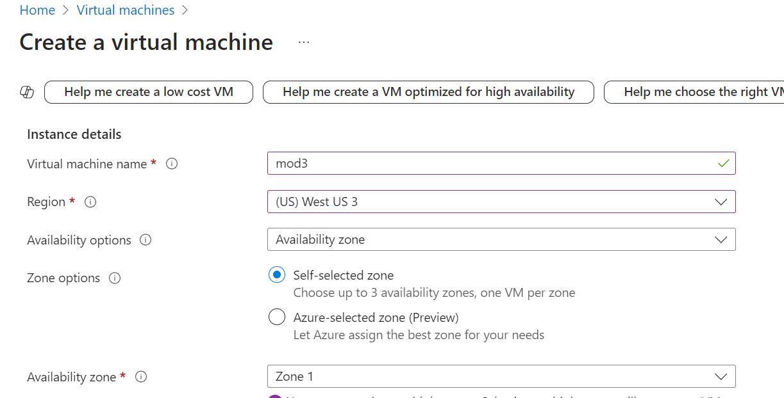

2. Open the RDP port

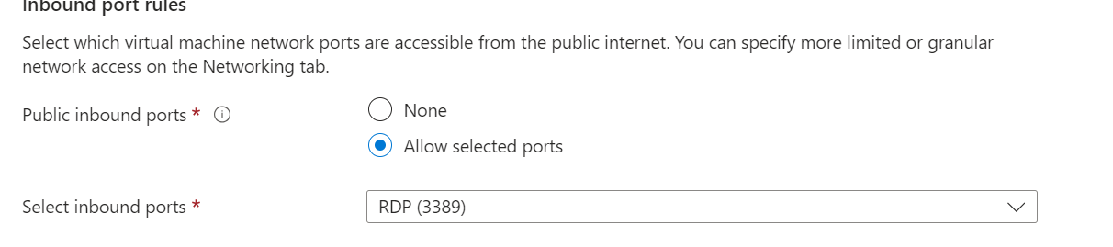

3. Connect to it using Windows Remote Desktop

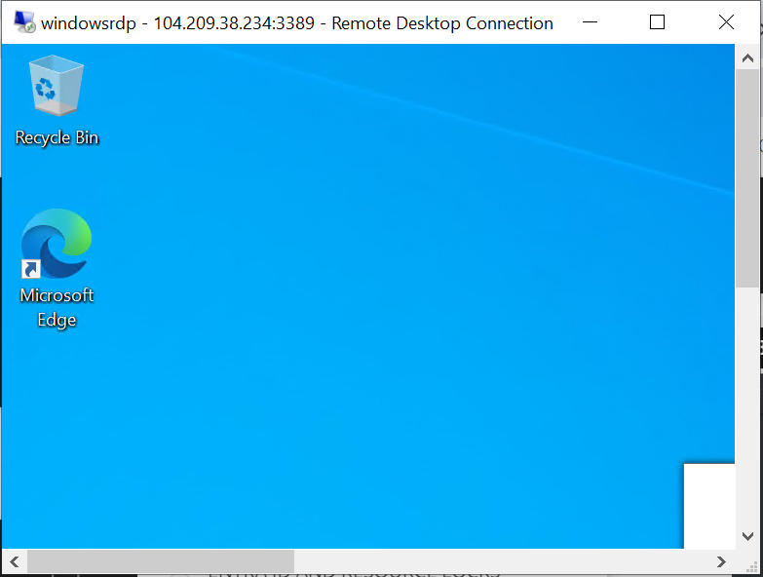

Module 4: Assignment – 3

1. Create a VM scale set with Ubuntu as OS

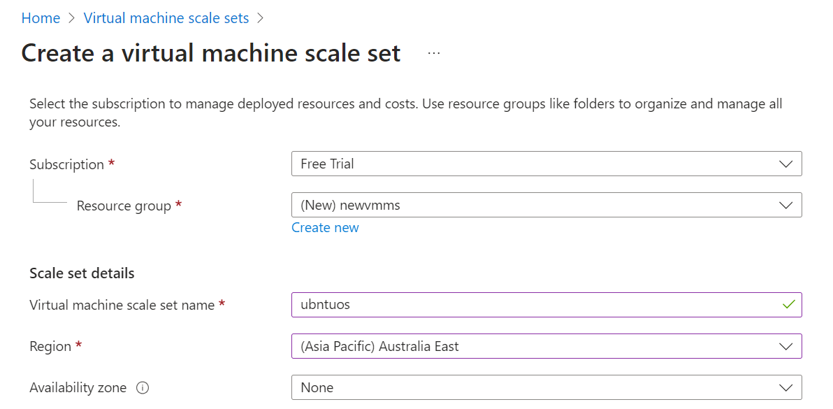

2. Give min VMs as 1 and a maximum as 5

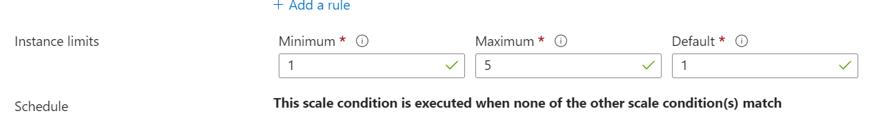

3. For scale-out CPU % is 75 and increases by 1 VM



4. For scale-in CPU % is 25 increase by 1 VM

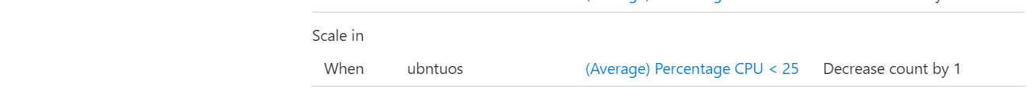

Module 4: Assignment – 4

1. Create a Linux VM with Ubuntu OS

Using existing Ubuntu OS

2. Install Apache2 software

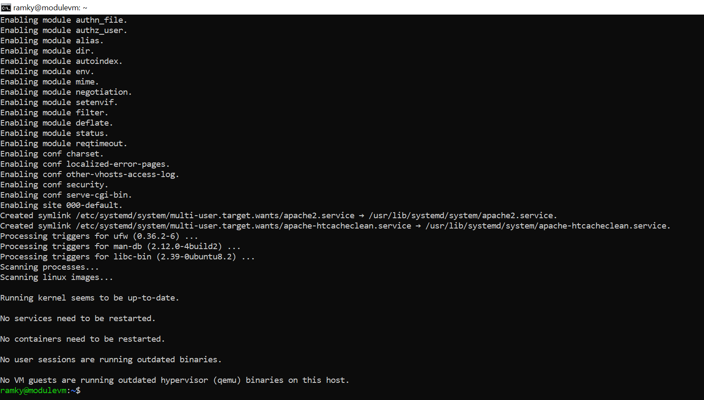

3. Create an image out of VM

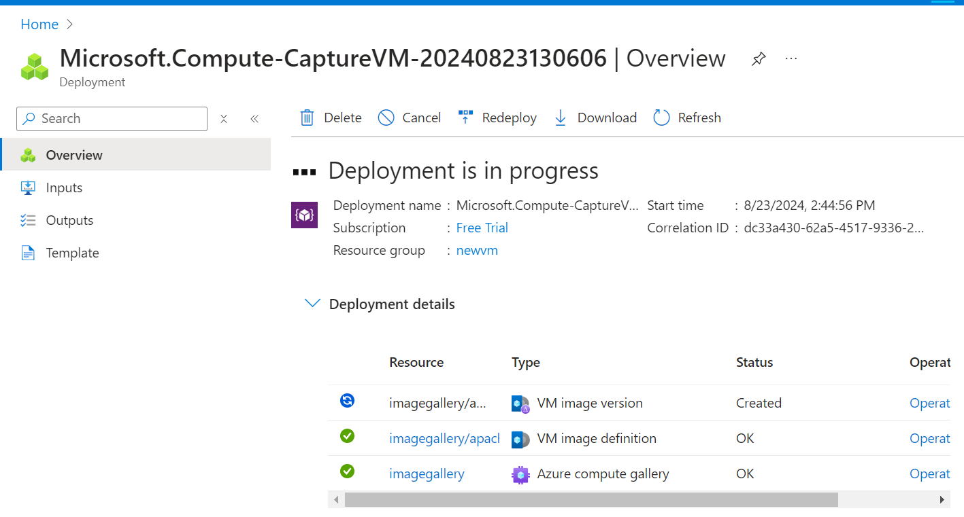

Module 4: Assignment – 5

1. Deploy a VM from the previously created image

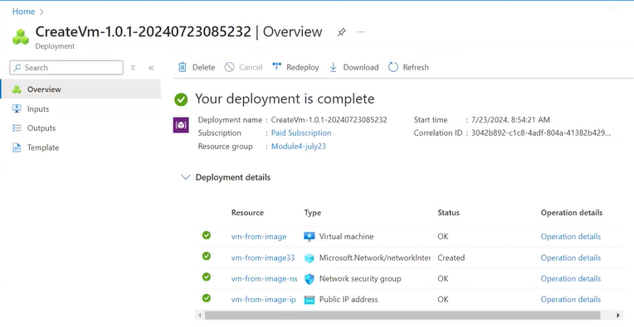

2. Open port 80 in NSG

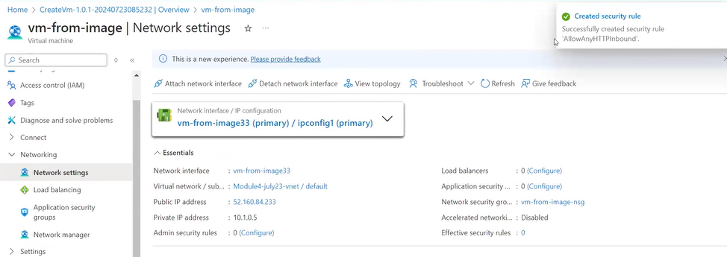

3. Start the Apache2 service in the VM

Added the HTTP and port number 80 then reached to website of Apache.

4. Verify if you are able to access the website

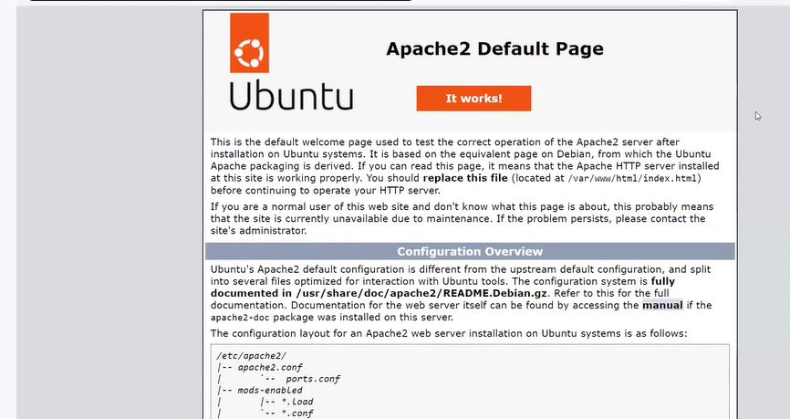

Module 5: Assignment – 1

1. Install a Docker using VM

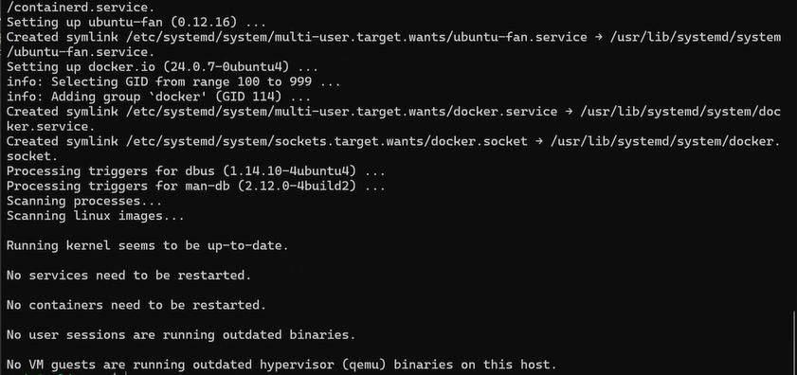

2. Pull hshar/webapp (https://hub.docker.com/r/hshar/webapp) repository

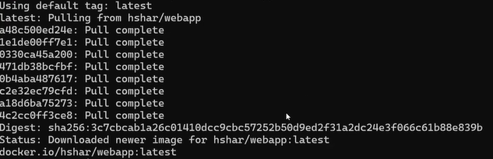

3. Create a new file in this repository



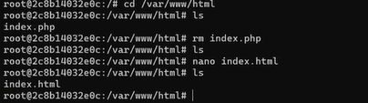

Module 5: Assignment – 2

1. Create an Azure Container Registry and connect it to Docker running in VM



2. Upload the image you created in this Azure to container registry

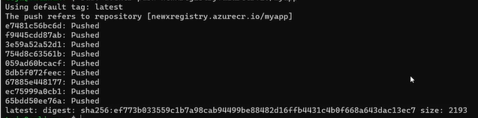

3. Create an app service to deploy the same image



Module 6: Assignment – 1

1. Create a virtual network in West US

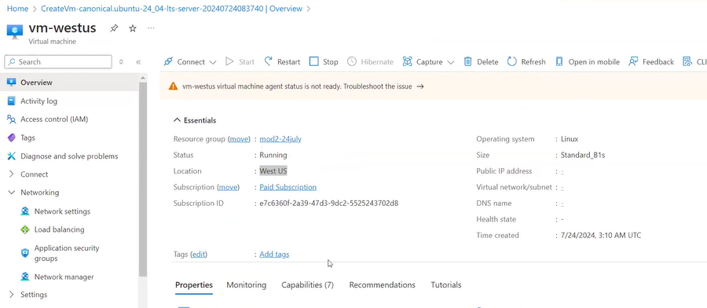

2. Create another virtual network in South India

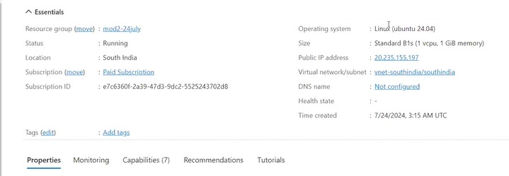

1. Deploy virtual machine in West US with the virtual network in West US

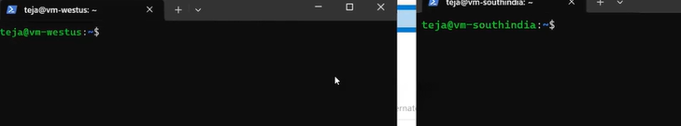

4. Deploy virtual machine in South India inside virtual network in South India

5. Create VNet-VNet peering to connect West US and South India VM

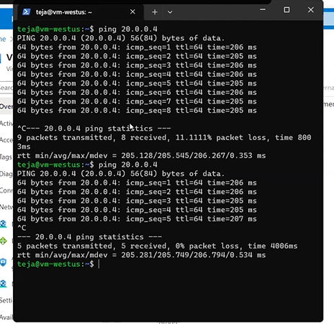

6. Check this by pinging VM1 to VM2 via ping command using private IP address

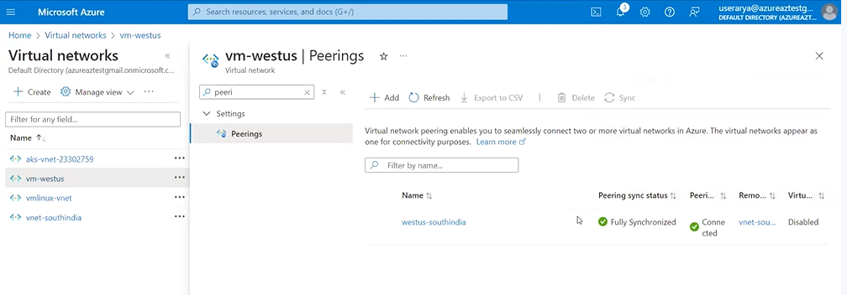

Module 6: Assignment – 2

1. Create a VM in West US



1. Assign a Static IP address to the VM

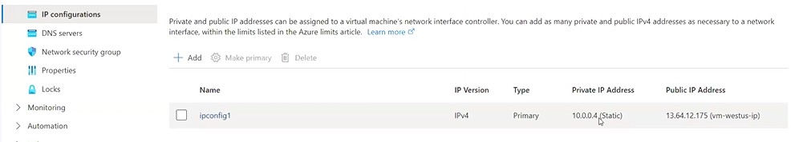

Module 6: Assignment – 3

1. Use the previously created VM



2. Created a NIC



3. Attach NIC to the previously created VM

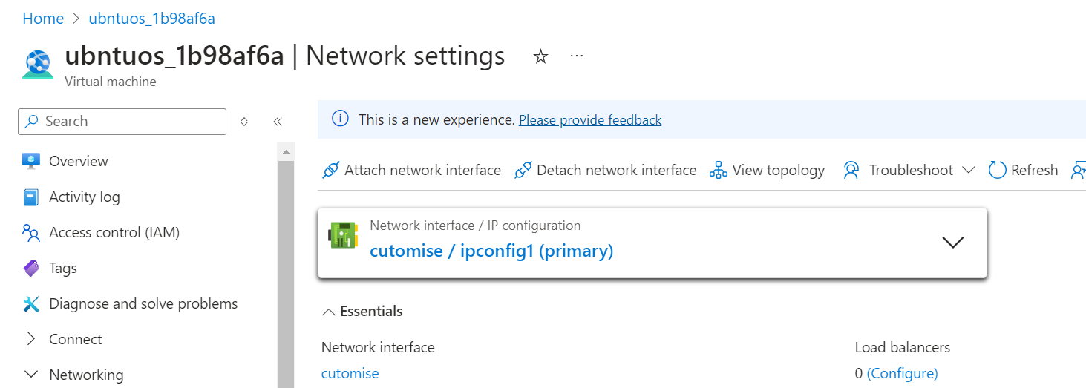

Module 6: Assignment – 4

1. Use the previously created Linux VM



2. Install Apache2 on this VM

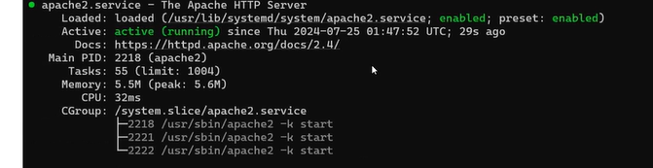

3. Create a Network Security Group to the subnet in which VM has been deployed

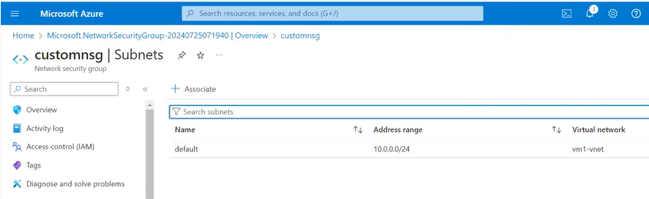

4. Open NSG rules for subnet and VM on port 80

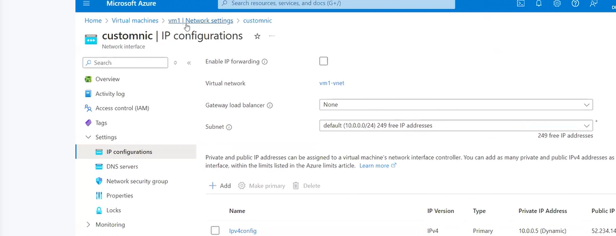

5. Verify if you can see the Apache2 page

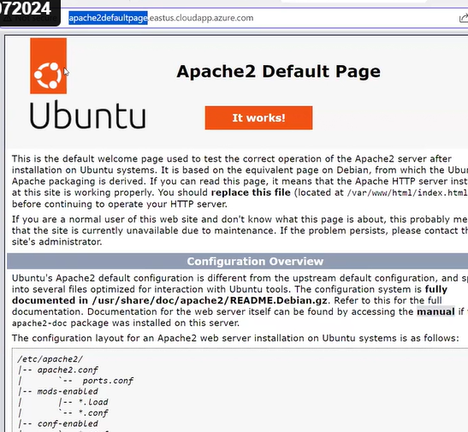

Module 6: Assignment – 5

1. Use the previously created Apache2 VM



2. Get a free domain from freenom.com

Don’t have freenom services

3. Use Azure DNS to point this free domain to your VMs IP

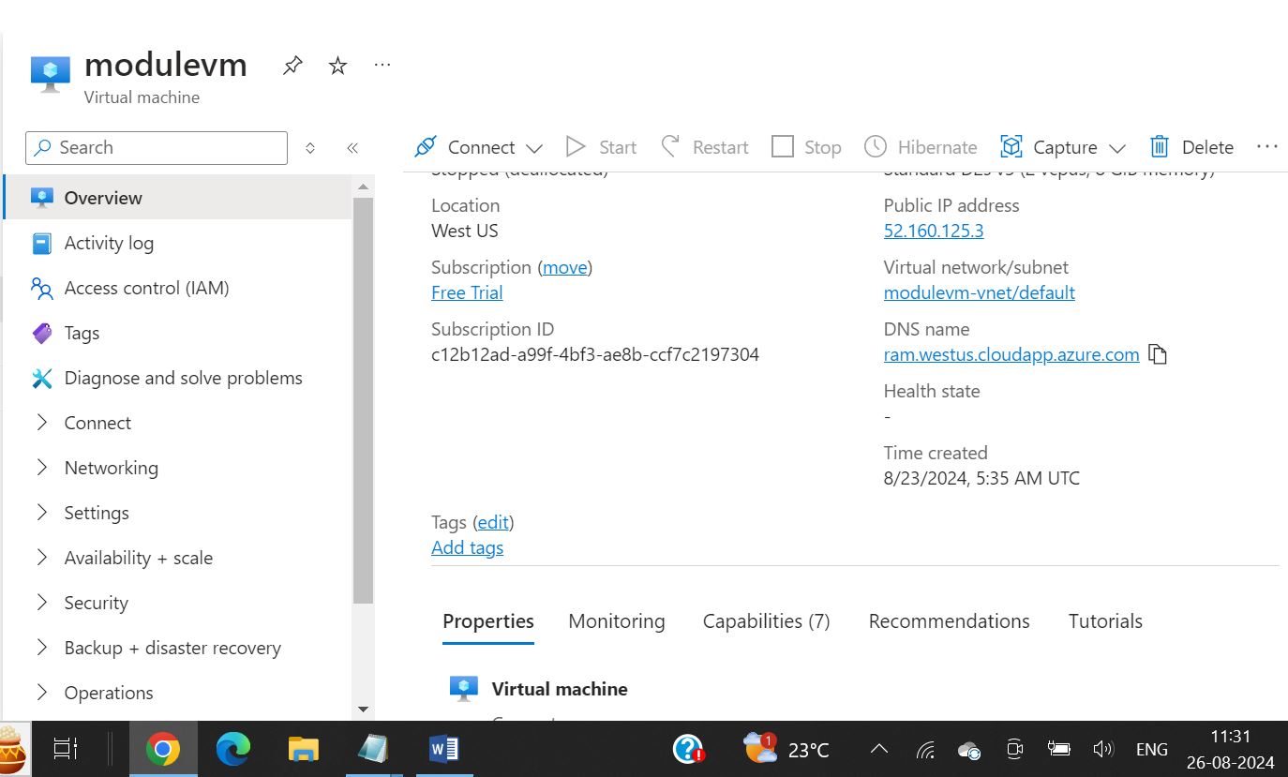

Module 7: Assignment – 1

1. Deploy 2 VMs with Ubuntu and Apache2 installed

2. Change index.html to include the following text

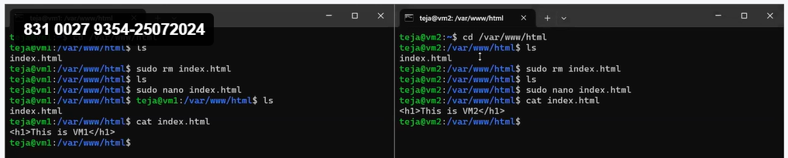

a. “This is VM1” on VM1

b. “This is VM2” on VM2

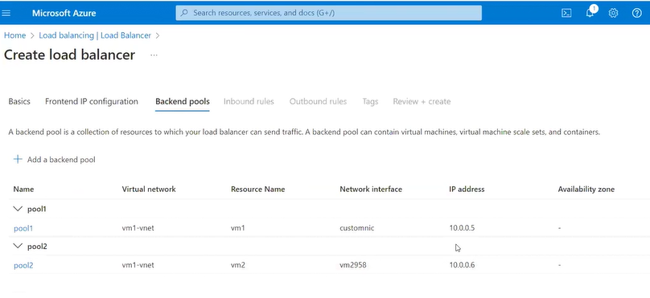

1. Create a load balancer which will balance the traffic between these two VMs

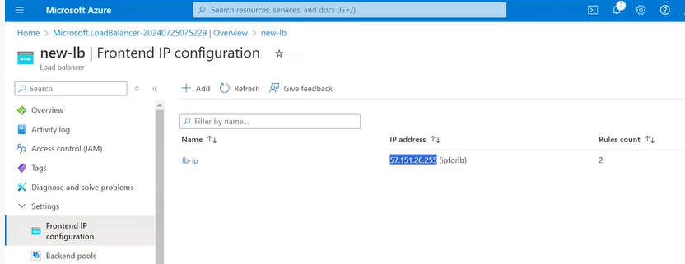

Module 7: Assignment – 2

Create an application gateway with the following configuration:

1. /vm1 should point to VM1

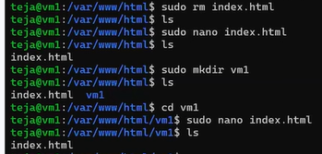



1. /vm2 should point to VM2

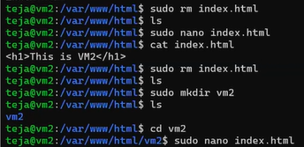

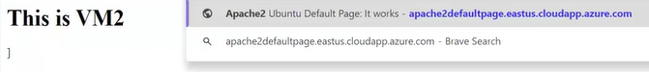

Module 7: Assignment – 3

1. For the two VMs deployed previously configure DNS for the public IPs of the VM

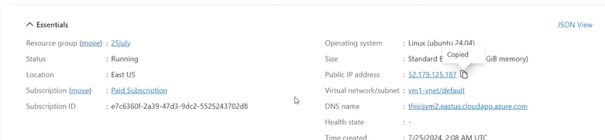

Module 7: Assignment – 4

1. Deploy 2 VMs in different regions

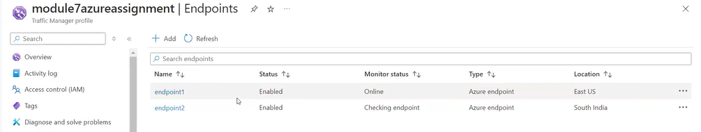

1. Balance the load on these VMs geographically To accomplish this please use Azure Traffic Manager



Module 7: Assignment – 5

1. Create a VM without public IP address

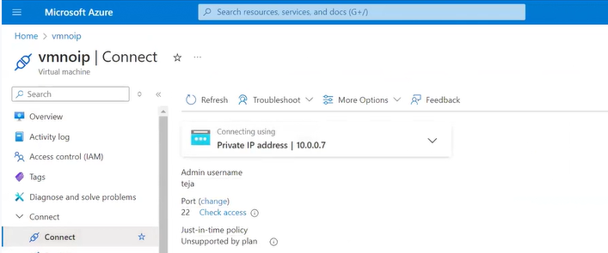

2. Connect to this VM using bastion host

